At 12.03pm on Tuesday 29 July 2025, the CEO having received apologies which indicated that a quorum would not be present, adjourned the meeting pursuant to Regulation 7(2) of the *Local Government (Procedures at Meetings) Regulations 2013* to 6:00pm on 24 August 2025.

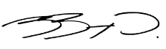

**Greg Georgopoulos**

**Chief Executive Officer**

**Adelaide Hills Council**